11.KNOWLEDGE MINING FOR ASSOCIATION RULES USING WEKA

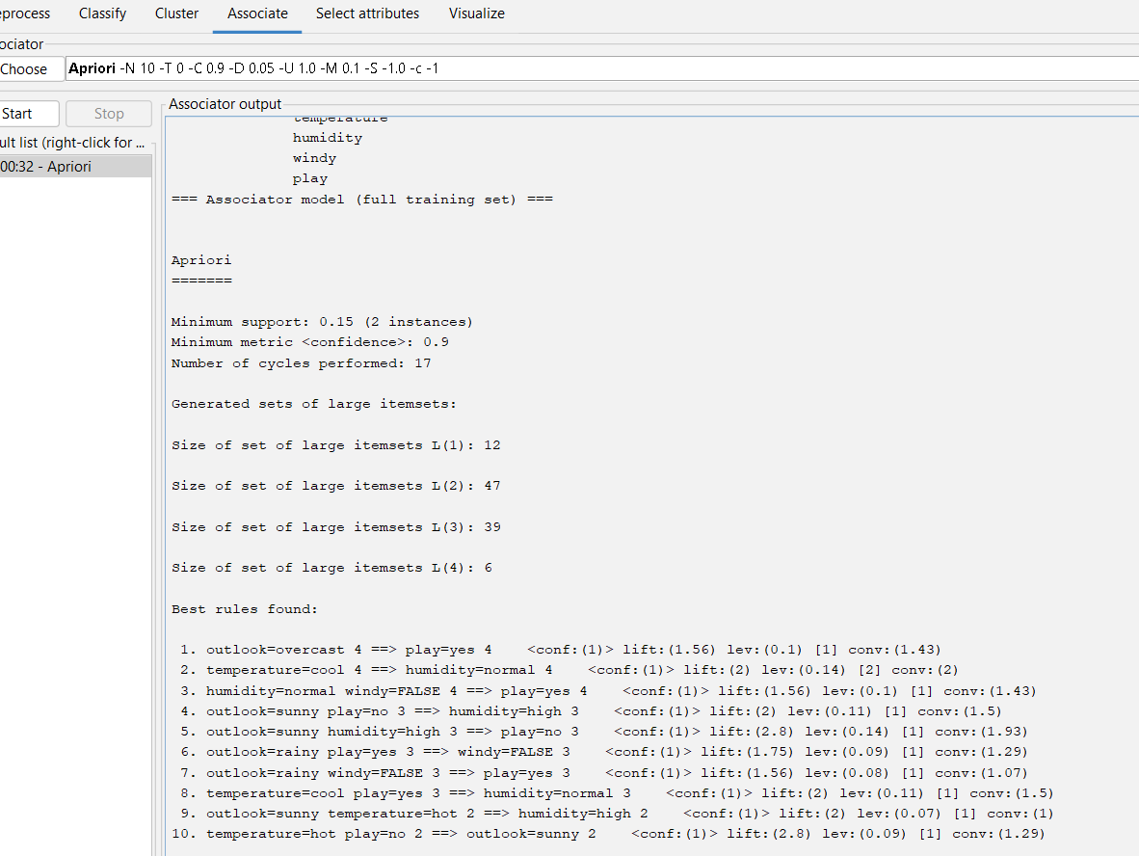

OUTPUT INFORMATION USING WEATHER NOMINAL DATA